Process – Lifecycle

* Process from generation to termination?
  + These are states in PCB
  + New State - > Program- process (Being Done)
  + Ready State -> Process is in memory in ready queue- > ready for execution from CPU
  + Running State -> P1 -> CPU allocate
  + Waiting State ->. Waiting I/O to complete
  + Terminated state -> process fininshed
  + 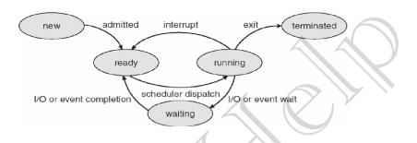
  + Process get into “new” from memory/disk
* Process Queues?
  + Job Queues:
    - Processes in New state reside here
    - Job Scheduler | Long term scheduler -> The method of scheduling the jobs from new state to ready state is done by job scheduler.
    - Job Schedular (Long term schedular (LTS)) picks process from the pool and loads them into memory for execution.
    - Present in secondary memory
    - Frequency is not very high. Has Idle time high
* Ready Queue:
  + Used for ready state to running state
  + CPU Schedular (Short-term schedular) picks process from ready queue and dispatch it to CPU.
  + Processes in Ready state. ii. Present in main memory
  + Idle Time is very low as frequency is very high
* Waiting Queue:
  + Processes in Wait state
* Degree of multiprogramming:
  + Amount of processes, that can fir into ready state at a time
  + Eg : 5 degree -> 5 processes in a ready state
  + LTS handles this as it bring processes from disk to ready state
* Dispatcher: The module of OS that gives control of CPU to a process selected by STS.

.